**CS6005- DEEP LEARNING**

**mini project on computer vision with transfer learning application**

**-BY**

**S.KARTHICKRAJA**

**2018103547**

**INTRODUCTION:**

The assignment for this project was to design and build classifiers that would effectively classify images of cats and dogs. One hundred sixty images, 80 cats and 80 dogs, were provided to the group as a training set. Each image was a 64 × 64 resolution gray scale image. Each team member chose a different strategy for a classifier, and experimented with the training set to determine its effectiveness. This was done by choosing a set of images (around 20% of the total) as a test set, training the classifier on the remaining images, and then computing the accuracy of the classifier using a “confusion matrix.” The basic strategy followed by each team member was:

• Transform the raw image data to features of lower dimension with minimal loss of information

• Employ a technique for classifying the images based on these features Once the classifiers were judged to be reasonably accurate using the training data, each was retrained on the complete set of 160 images, and then used to classify 38 new (19 cats and 19 dogs). In the next sections, we give the details of each classifier and its accuracy results

**DATASET:**

**The Asirra (Dogs VS Cats) dataset:**

The Asirra (animal species image recognition for restricting access) dataset was introduced in 2013 for a machine learning competition. The dataset includes 25,000 images with equal numbers of labels for cats and dogs.



The Dogs vs. Cats dataset is a standard computer vision dataset that involves classifying photos as either containing a dog or cat.

Although the problem sounds simple, it was only effectively addressed in the last few years using deep learning convolutional neural networks.

TRANSFER LEARNING:

**Transfer learning** is an optimization that allows rapid progress or improved performance when modeling the second task. **Transfer learning** is the improvement of **learning** in a new task through the **transfer** of knowledge from a related task that has already been learned.

In this project,

Three Convolutional models are developed in this module

• CONVNET 3 with features from pretrained model

• CONVNET 4 - Pre-Trained Model as Feature Extractor in Model

o CONVNET 5 – MODEL 4 with frozen layers from pretrained model

o CONVNET 6 – MODEL 4 with Fine tuning of pretrained model

**MODULES:**

**Convolution layer building:**

Two Convolutional models are developed in this module

• CONVNET 1 without Data augmentation Parameters

• CONVNET 2 with Data augmentation Parameters

**IMPORTING NECESSARY LIBRARIES:**

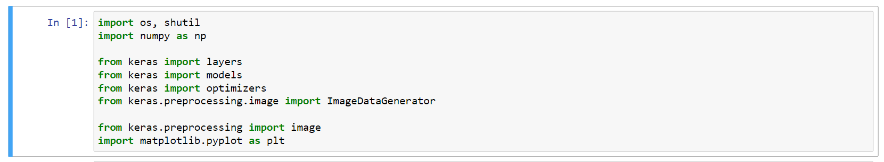

**LOADING DATASET :**

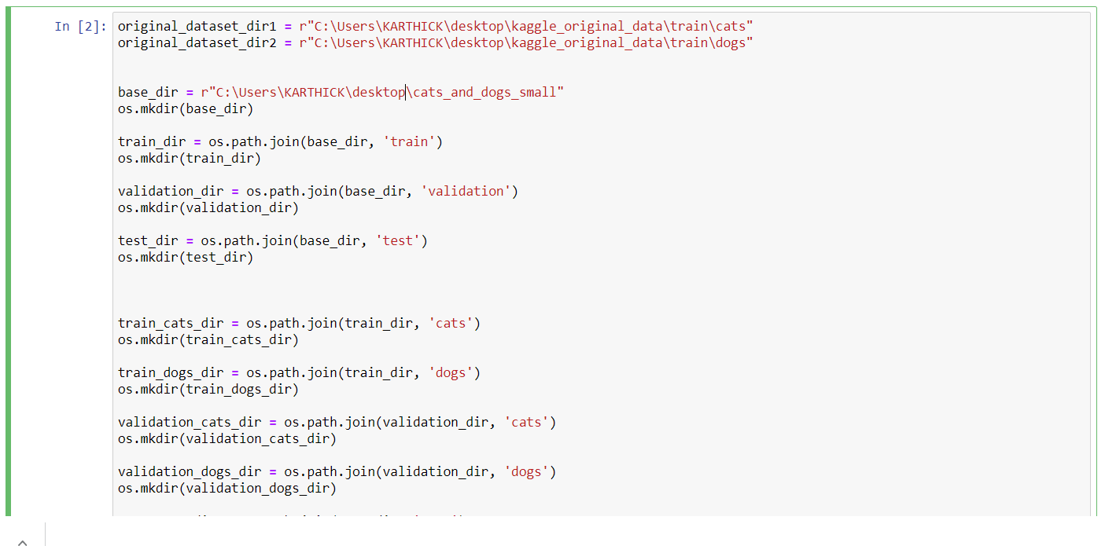

**PREPROCESSING:**

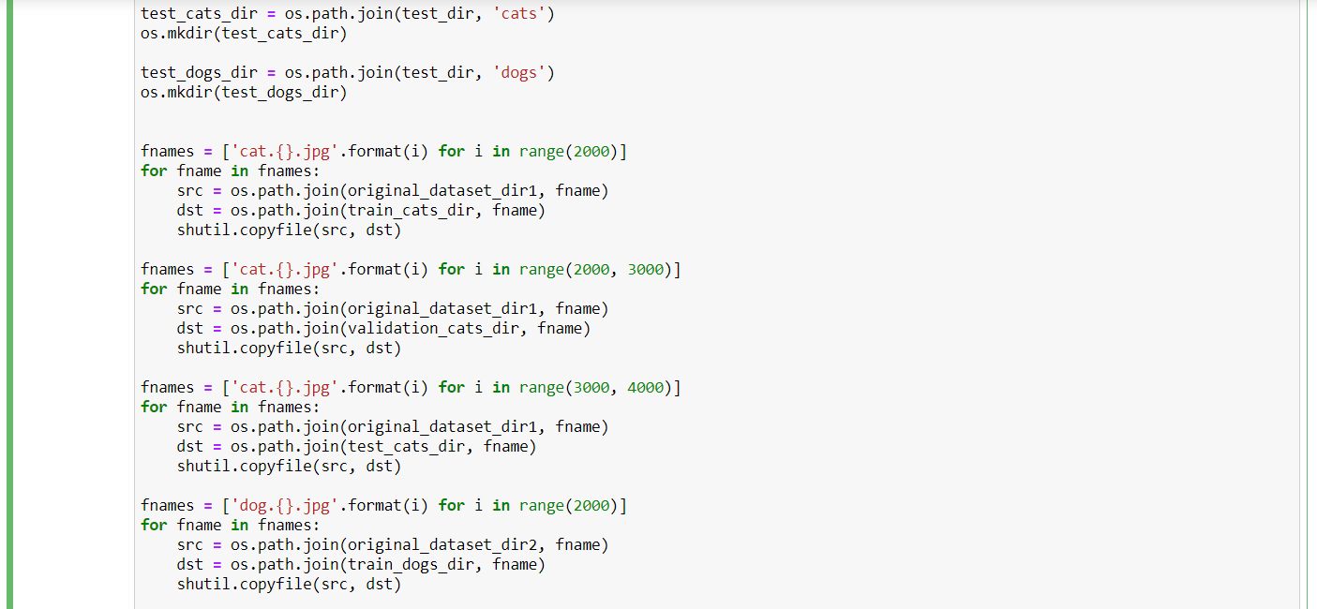

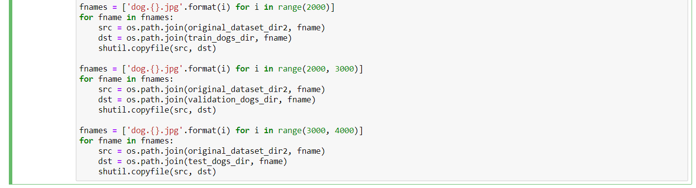

**PRINTING THE AVAILABLE DATASET INFO:**

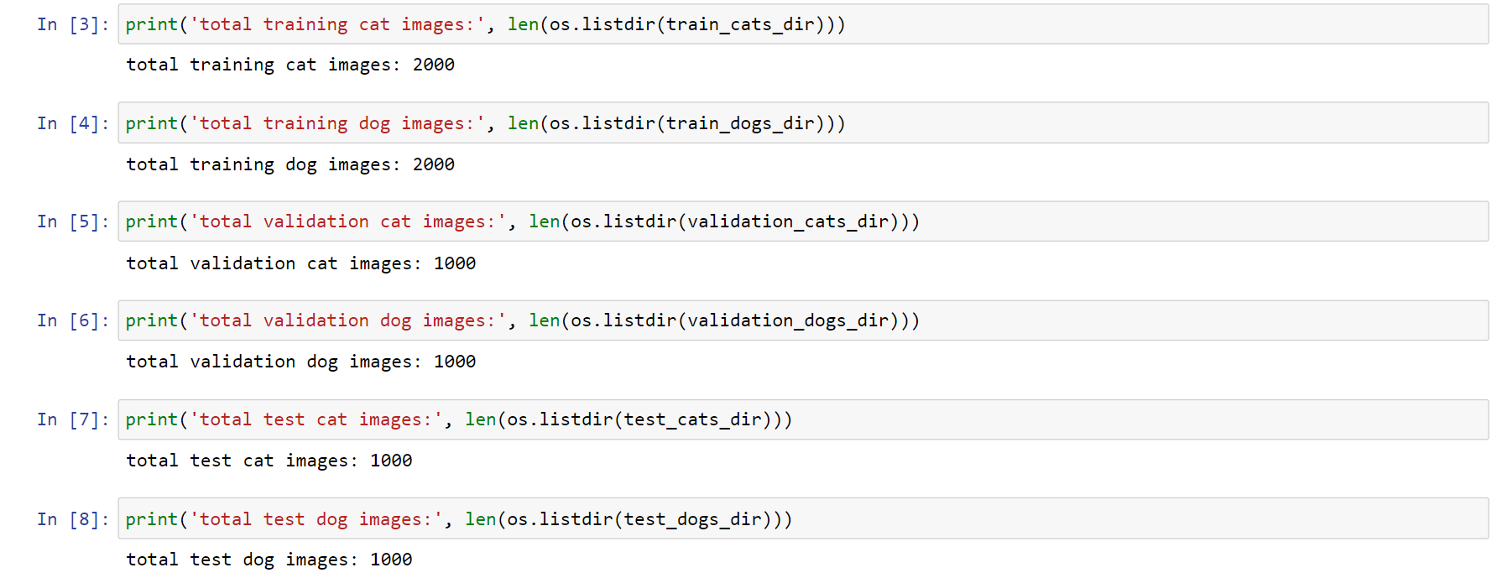

**BUILDING MODEL:**

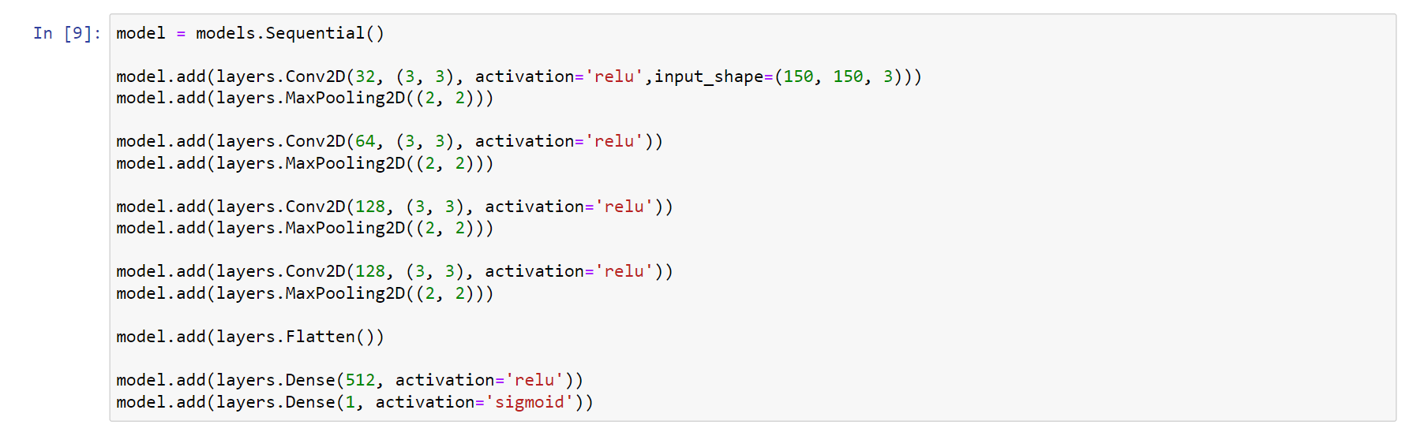

**OBTAINING SUMMARY:**

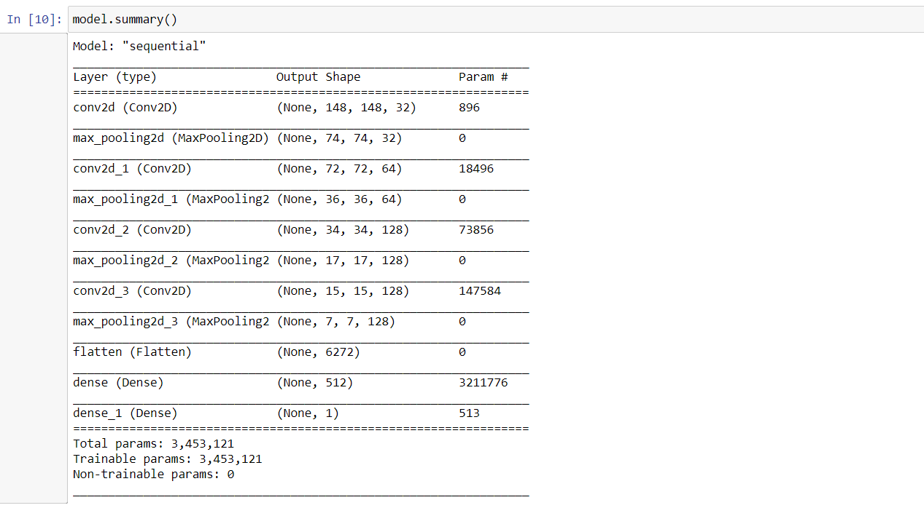

**COMPILING THE MODEL:**

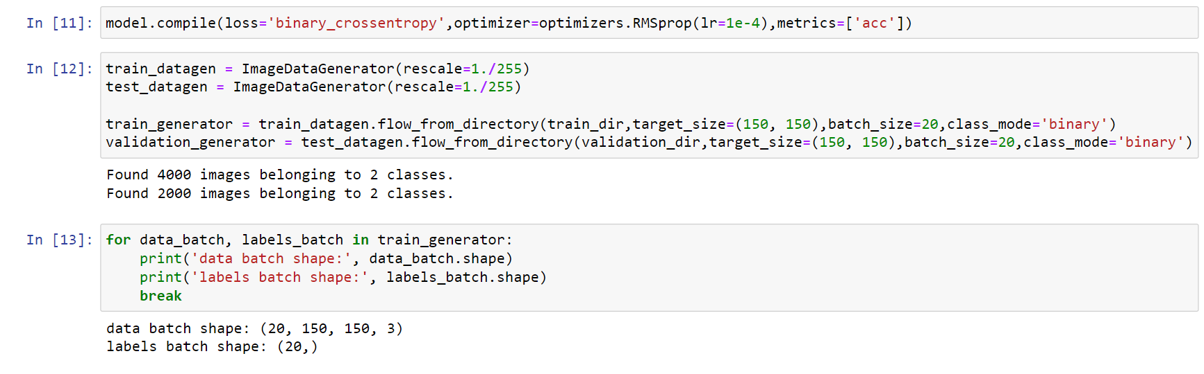

**FITTING THE MODEL:**

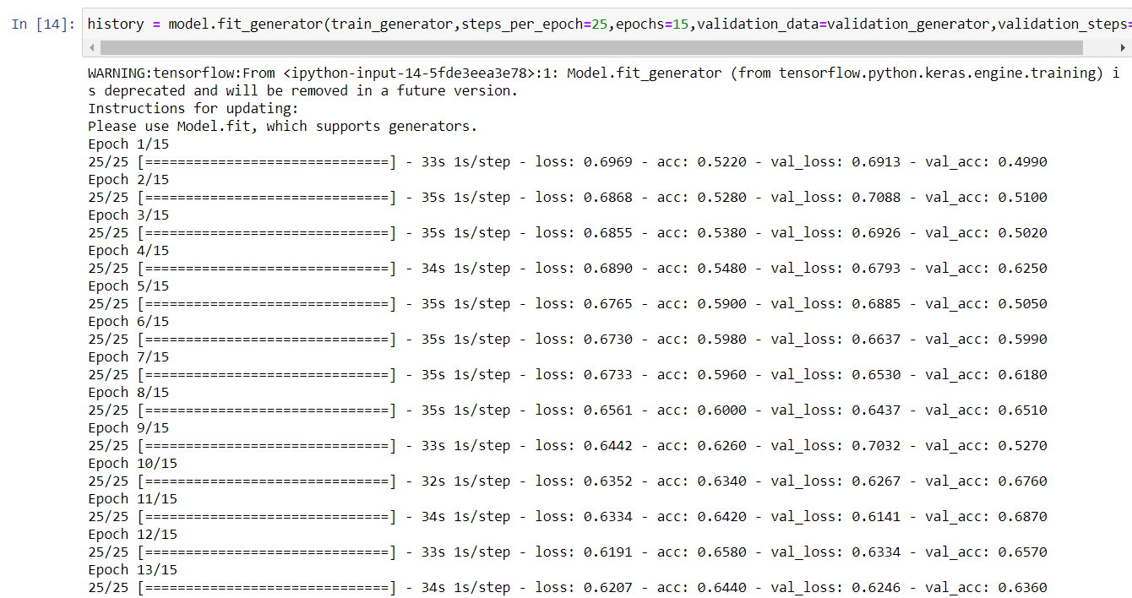



**Accuracy is 68%.**

**PLOTTING:**

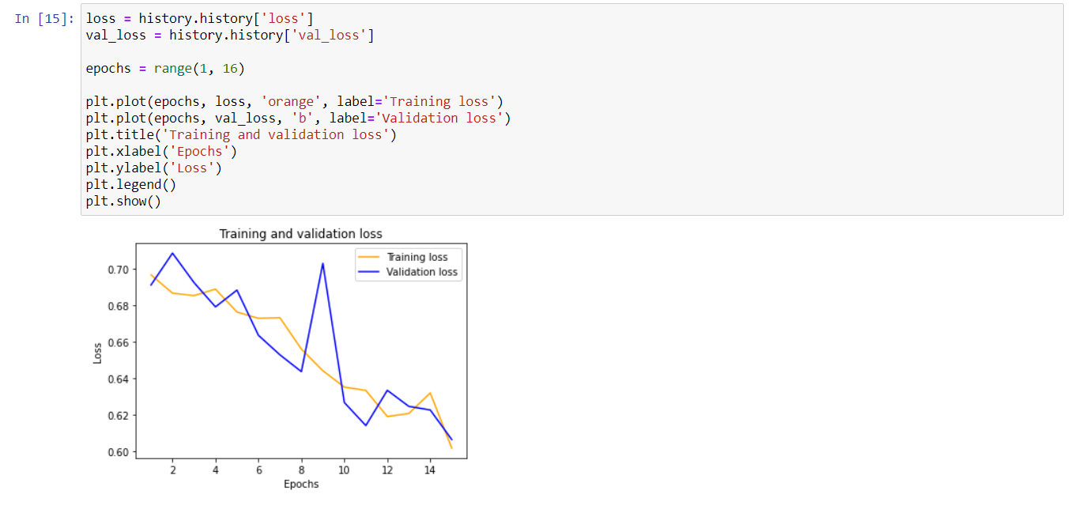

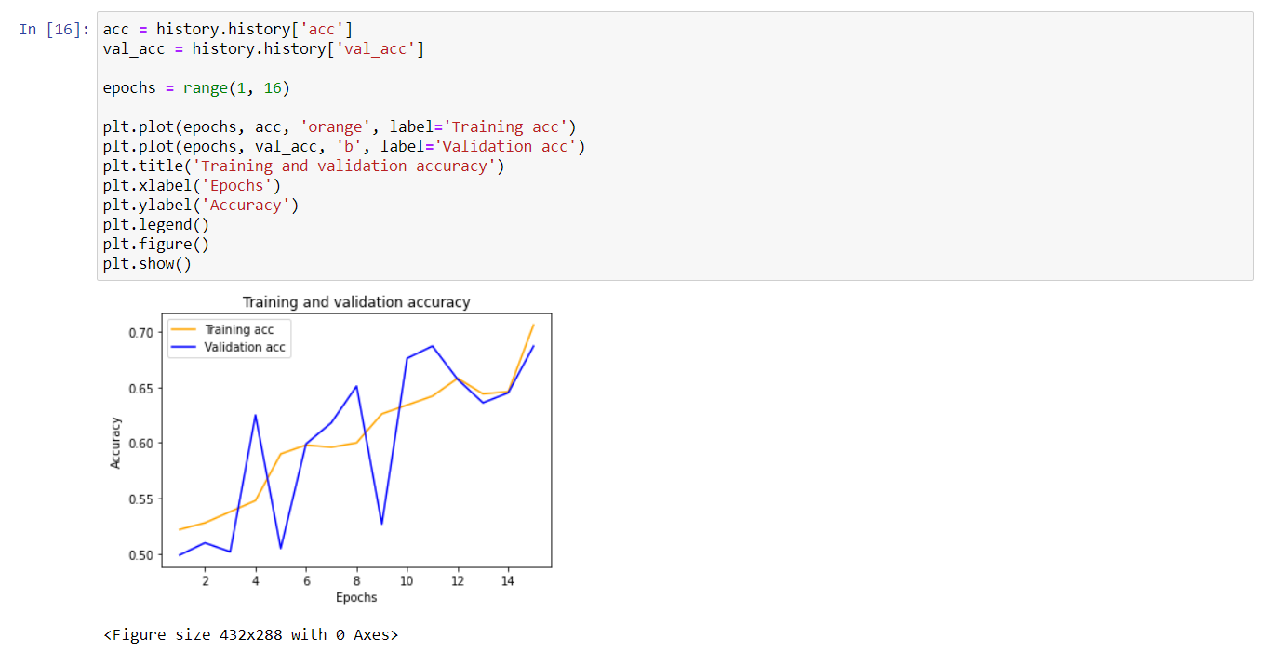

**IMAGE PLOTTING WITH DATA AUGMENTATION:**

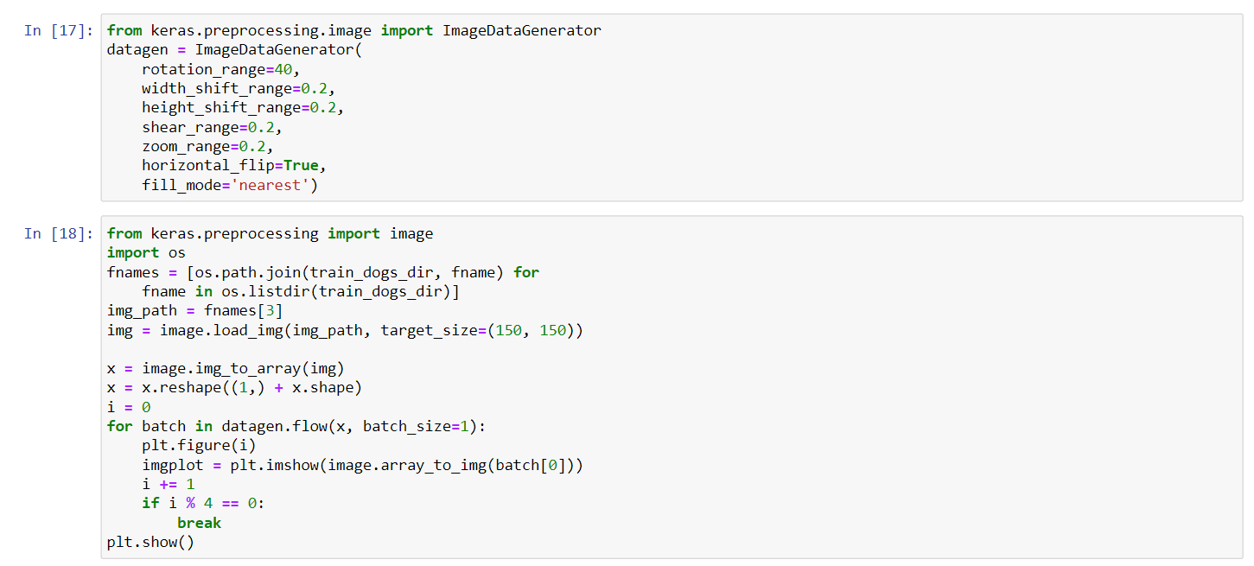

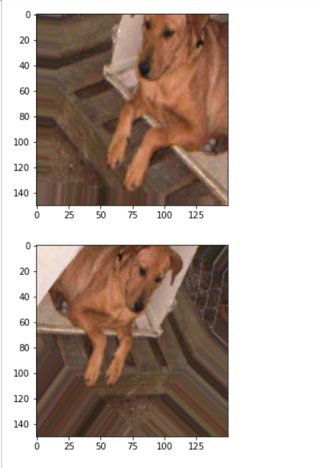

**COVNET Model :**

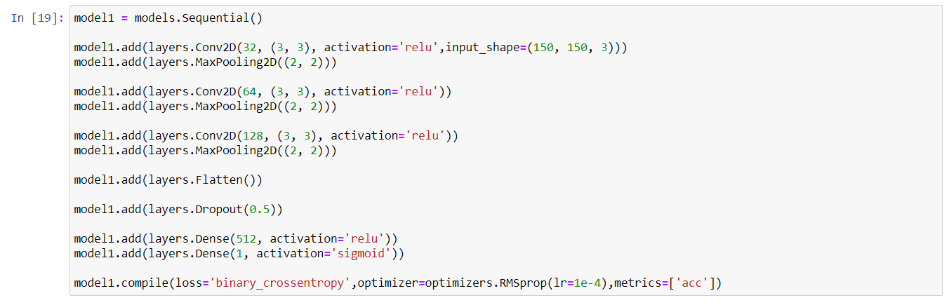

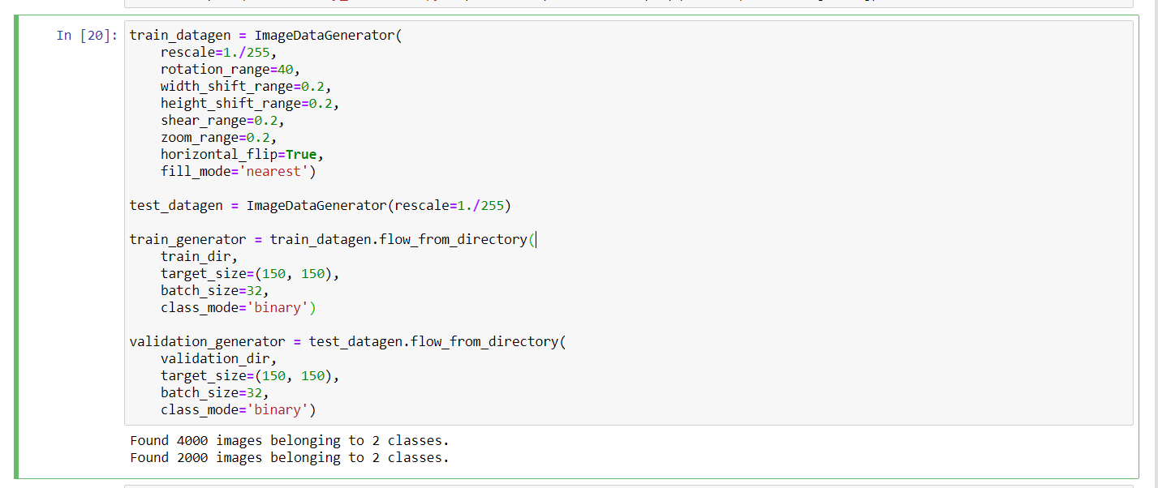

**PLOTTING:**

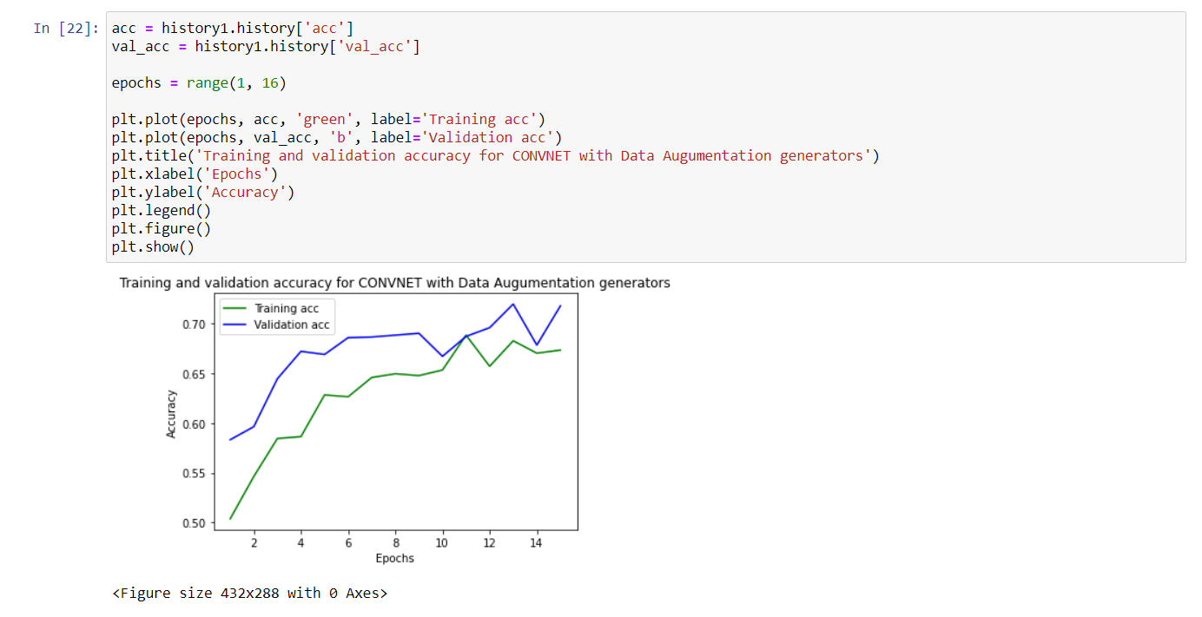

**Fitting the covnet model:**

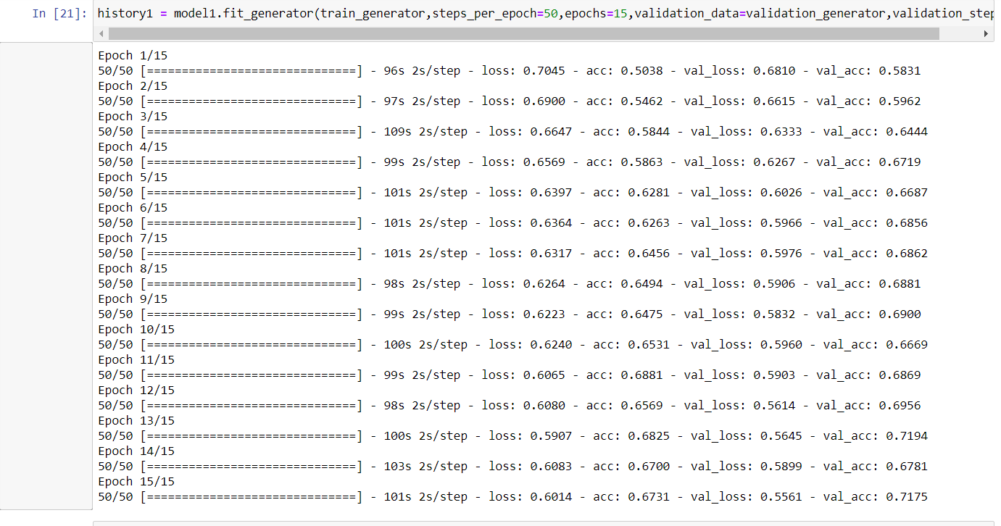

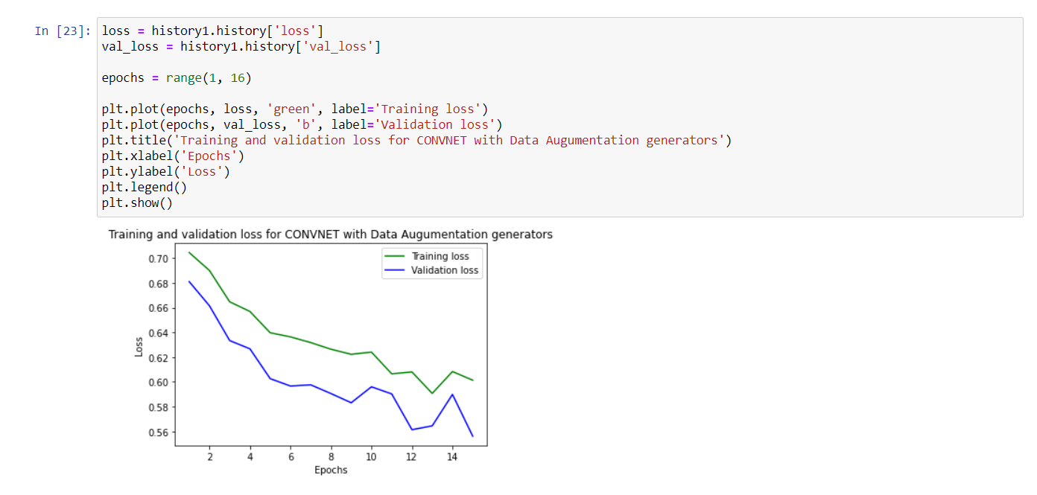

**SUMMARY:**

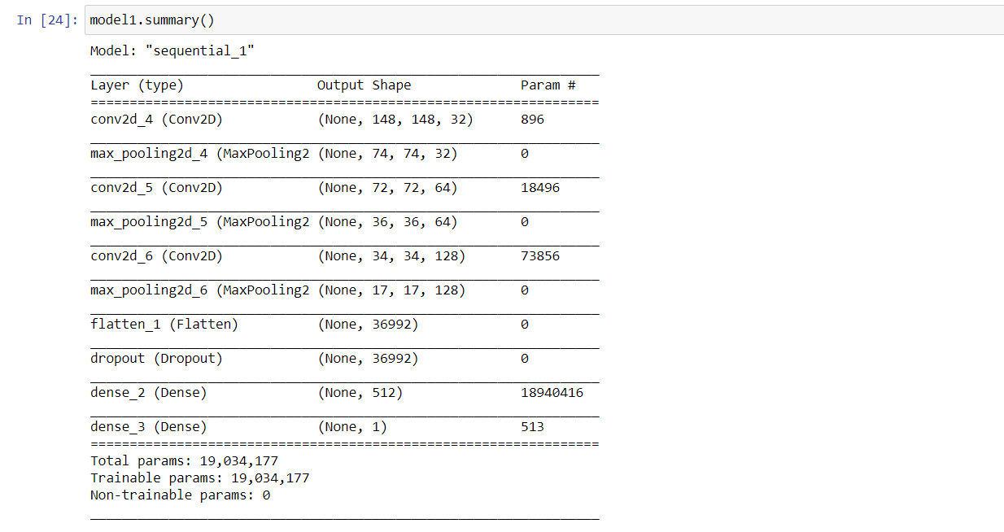

**VGG16:**



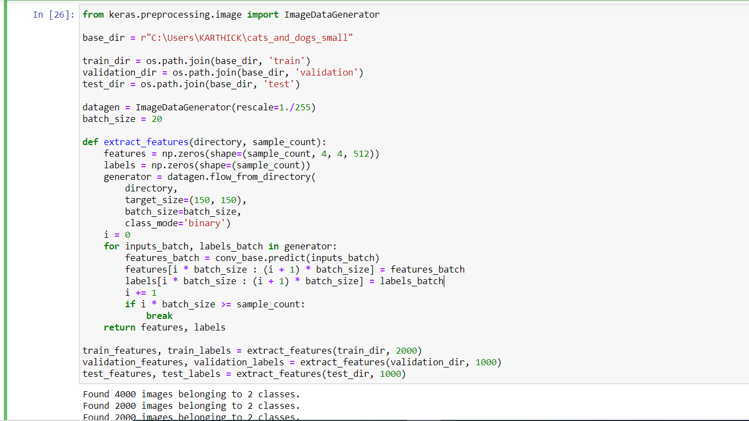

**TRAINING the VGG16 model:**

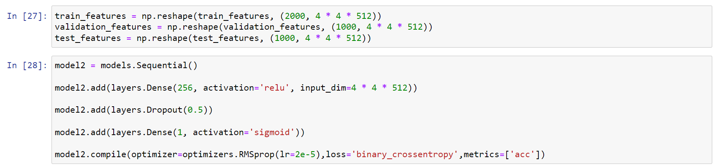

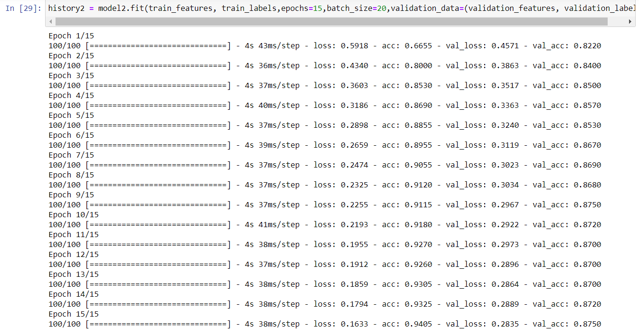

**PLOTTING:**

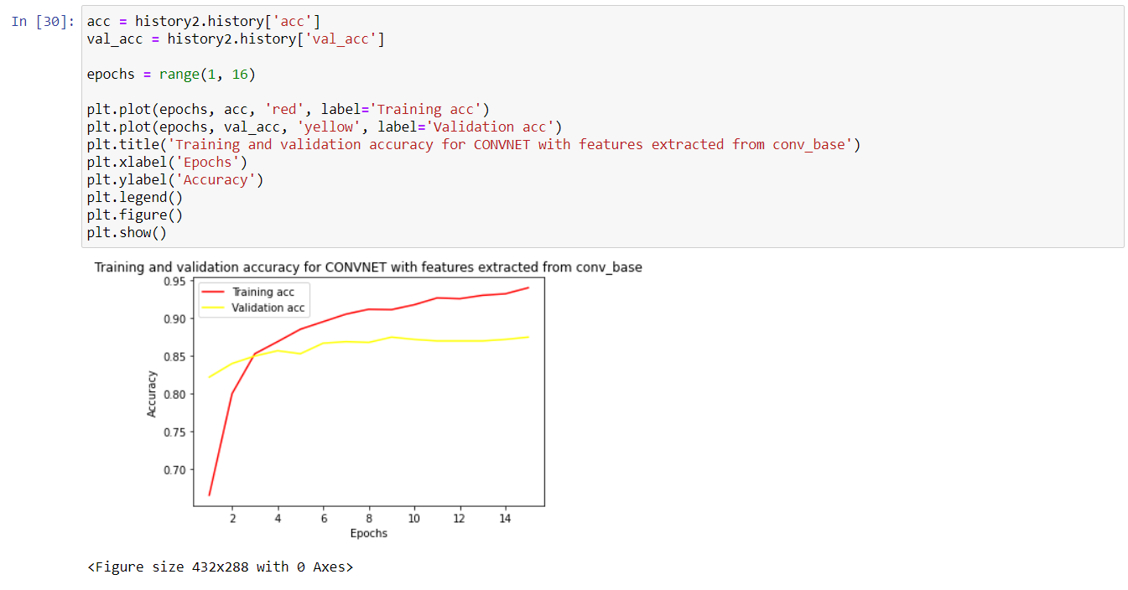

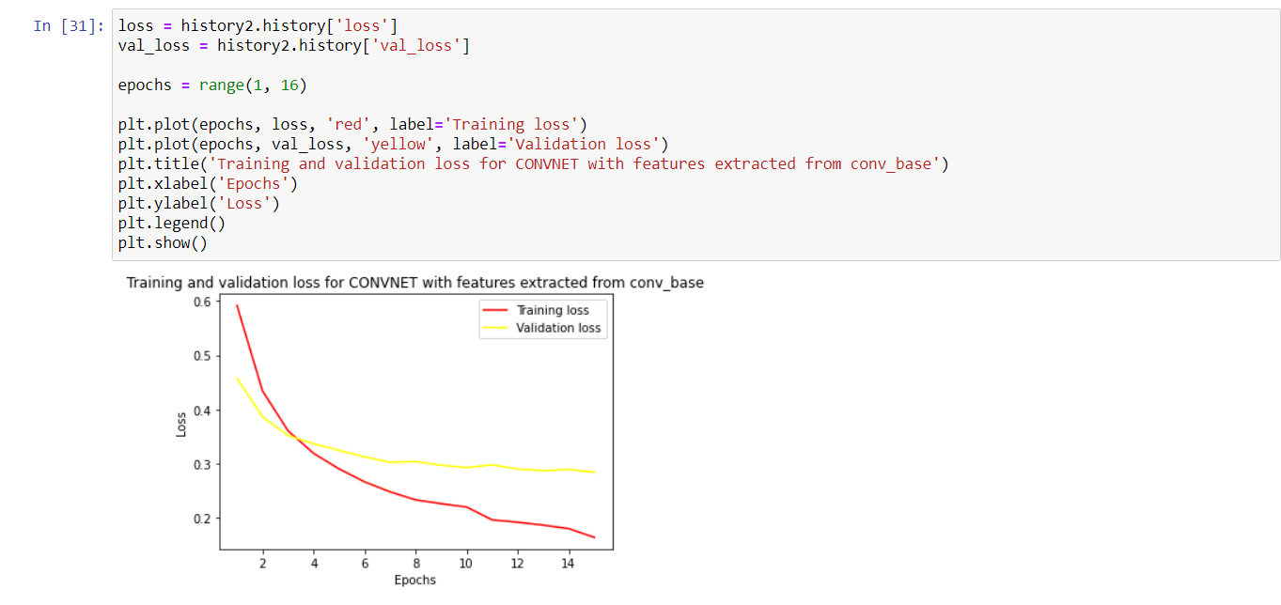

**SUMMARY:**

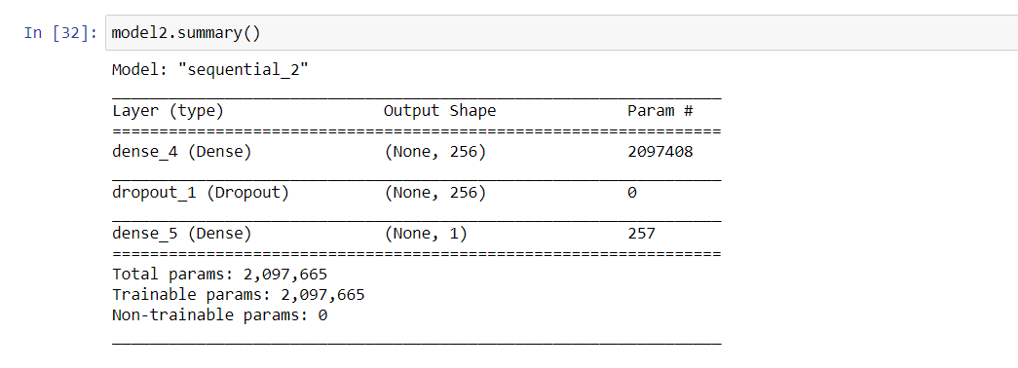

**COVNET 4:**

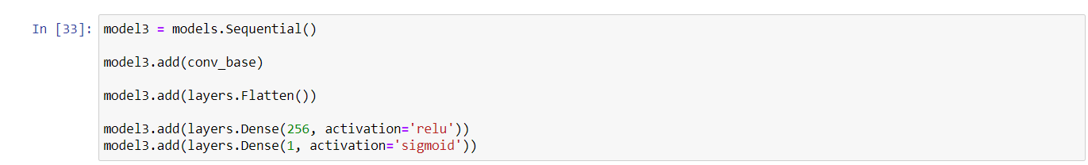

**CONVNET 5 – MODEL 4 with frozen layers from pretrained model**

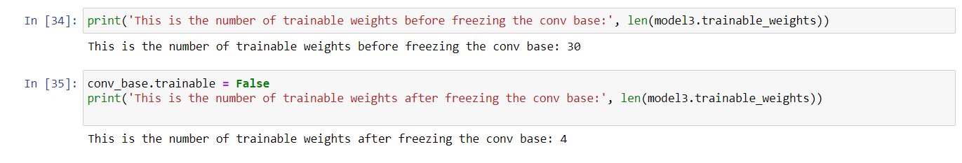

**FITTING THE MODEL:**

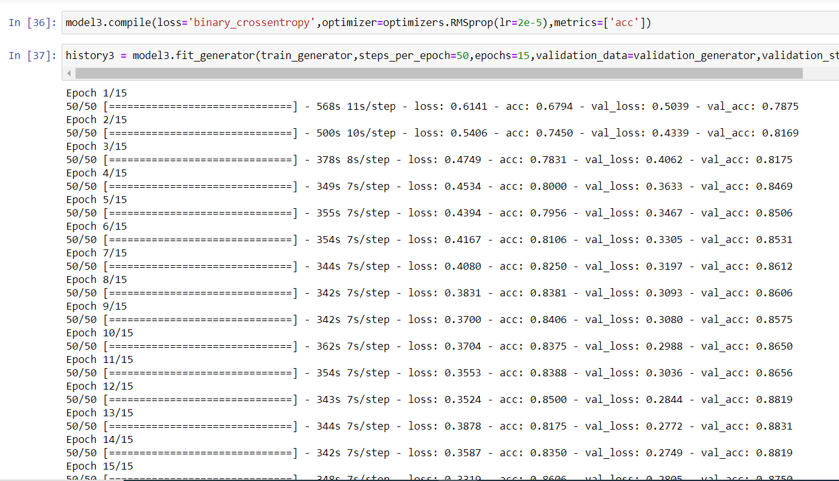

**PLOTTING:**

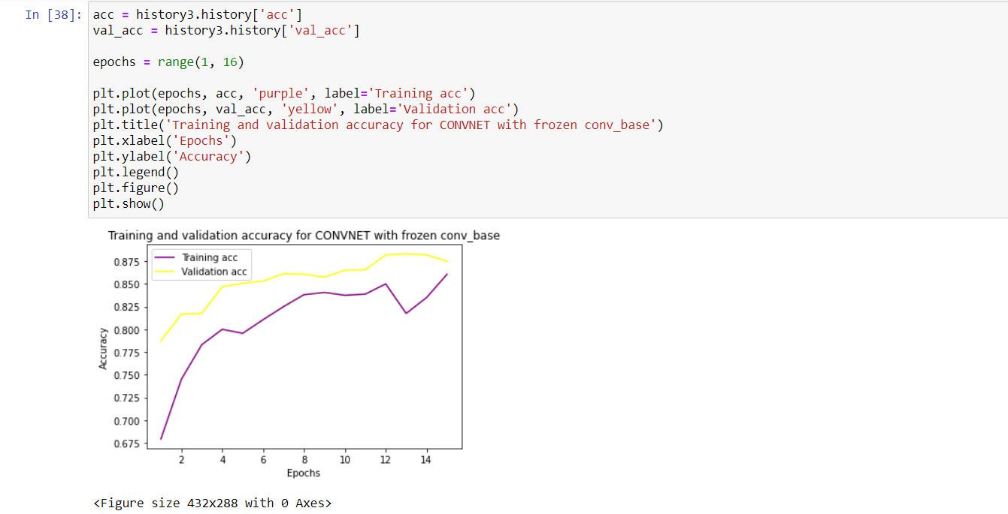

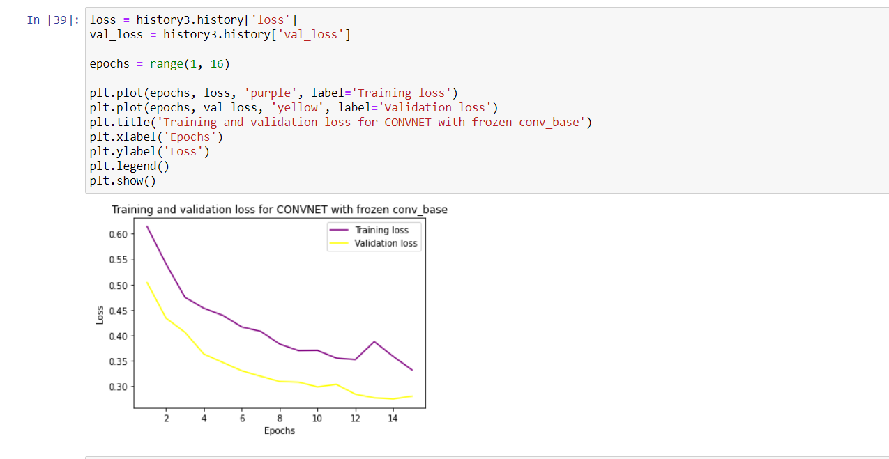

**SUMMARY:**

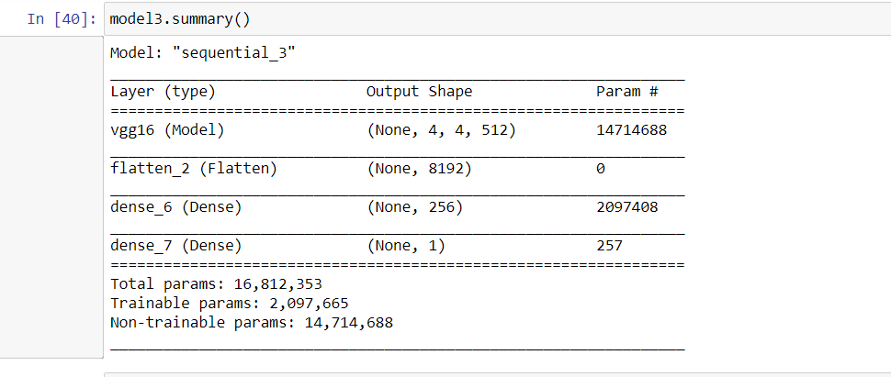

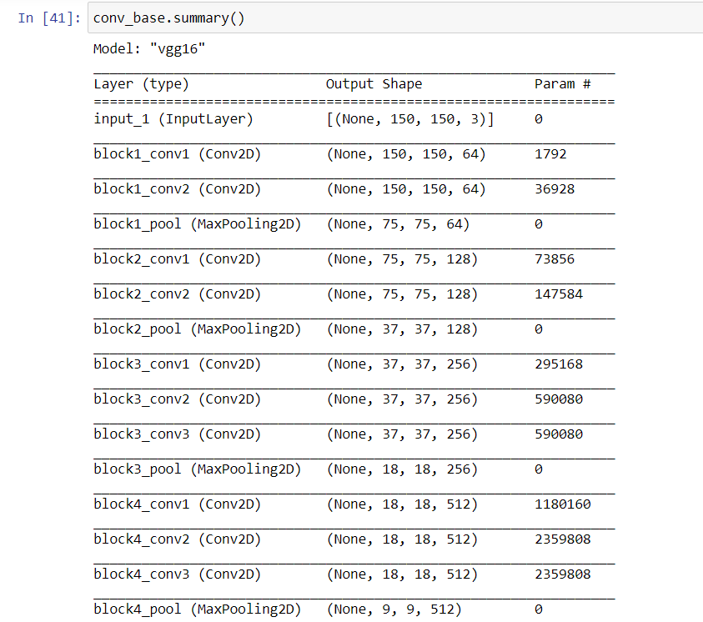

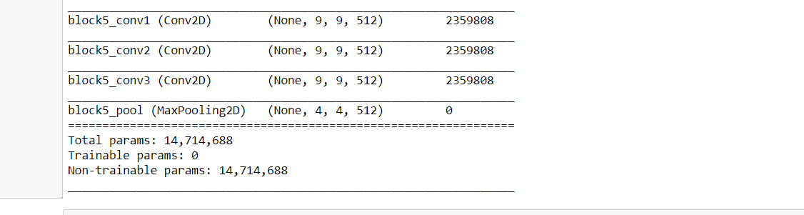

**COMPILING & TRAINING :COVNET 6 model 4 with Fine tuning of pretrained model:**

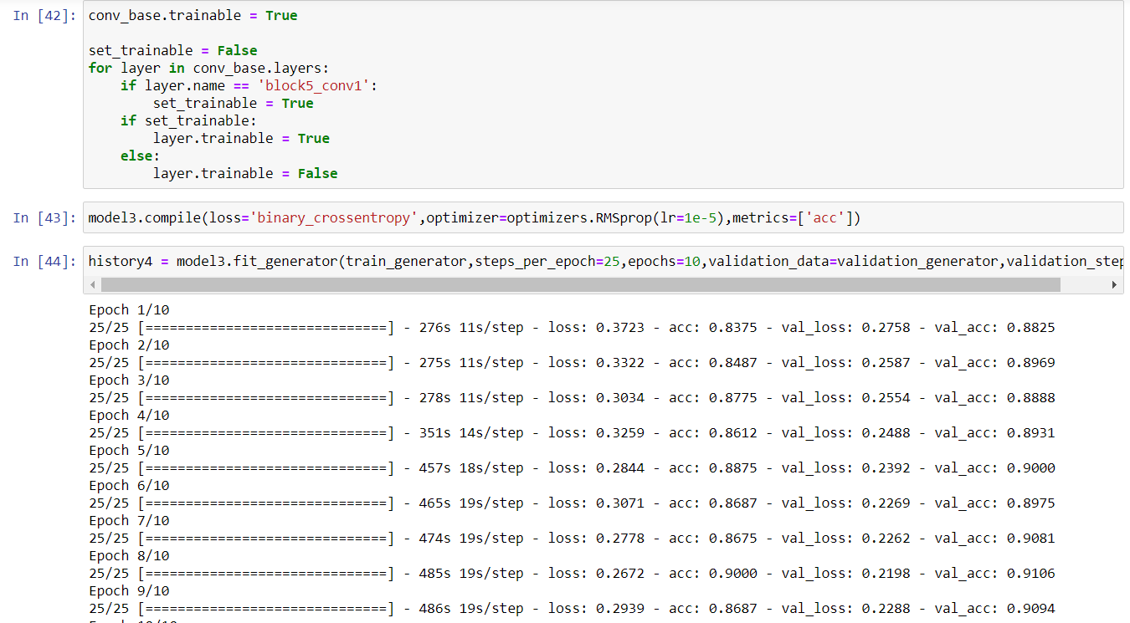

**PLOTTING:**

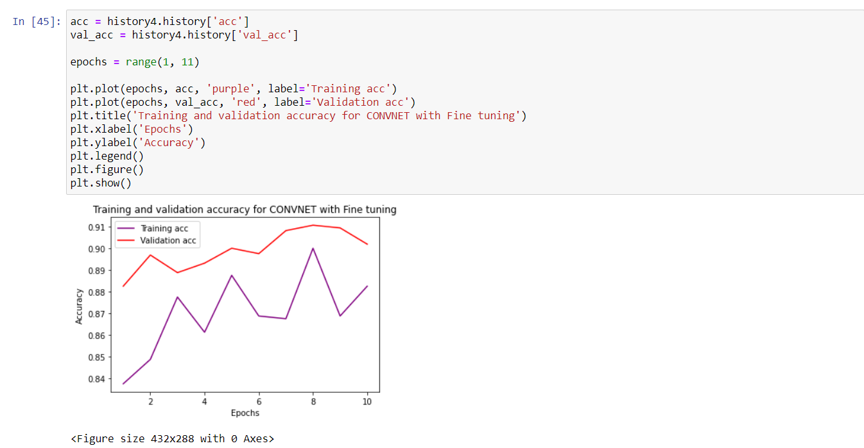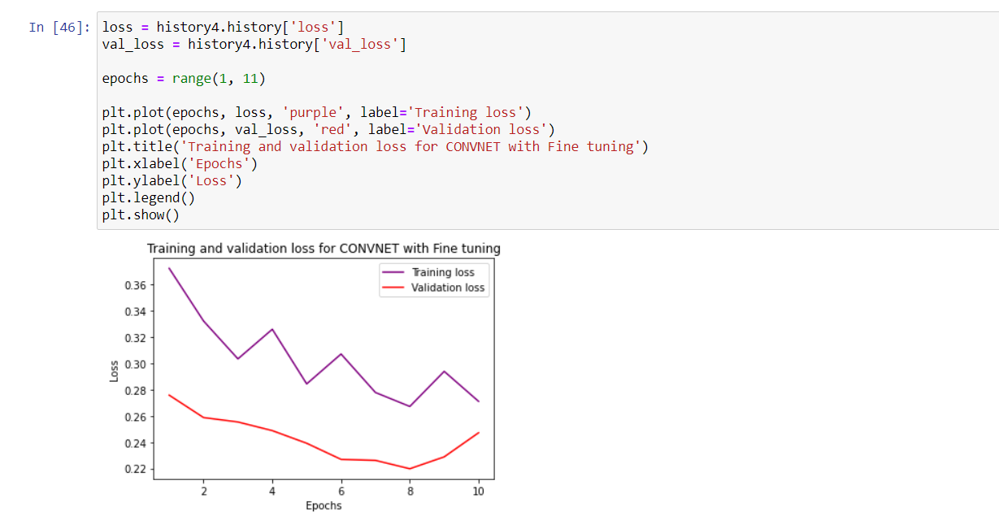

**EVALUATION:**

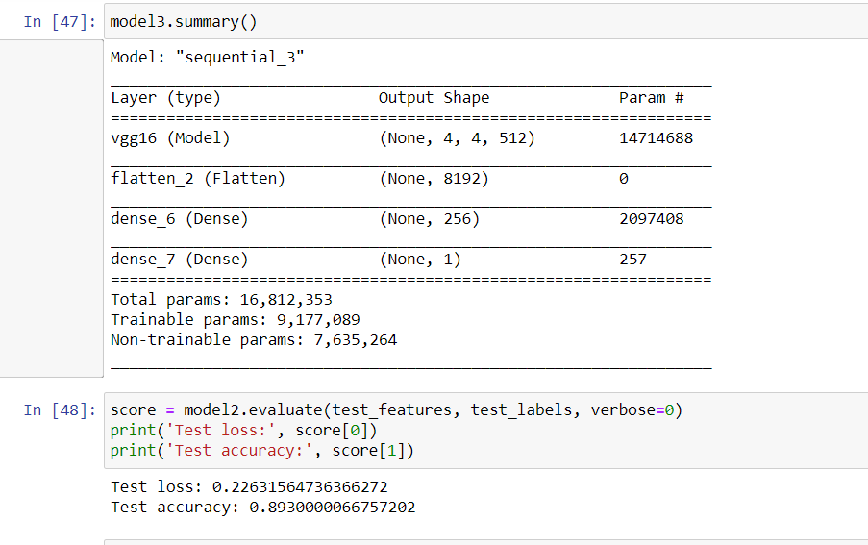

**ACCURACY: 89%**

**PREDICTION:**

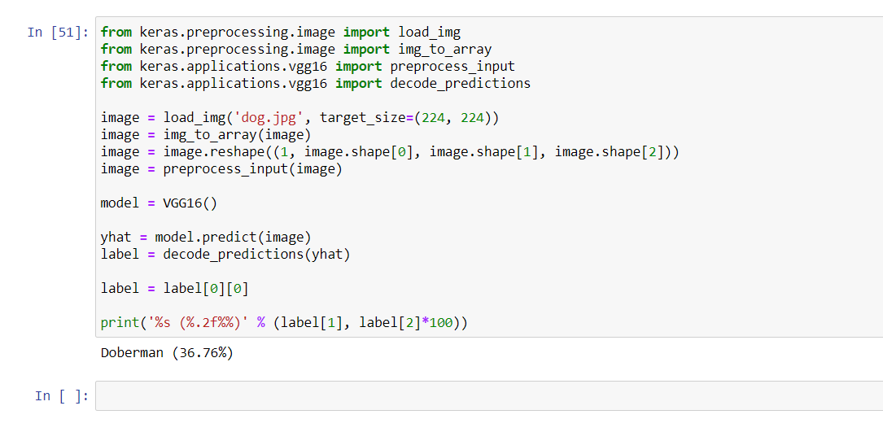

**CONCLUSION:**

Computational power for classifying image dataset is much less for CNN when compared to other learning models because it uses advanced feature extraction technique which uses filters, kernel, pooling etc.. to extract features from image.

**REFERENCES:**

* <https://www.kaggle.com/c/dogs-vs-cats>
* <https://www.kaggle.com/sarvajna/dogs-vs-cats-keras-solution>